

**CIS 11051 – PRACTICAL FOR DATABASE DESIGN**

Information and communication Technology

Faculty of Technology

South Eastern University of Sri Lanka

Registration Number: SEU/IS/22/ICT/075

Academic year: 22/23

LabSheet01

## **Exercises**

1. Open MS Access -> click on “Blank database” -> type the “name” and click on “Create”.

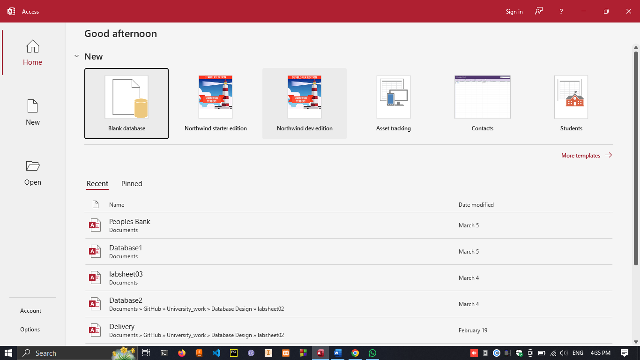

1. a. under Create ribbon tab -> click on “table”

b. under Create ribbon tab -> click on “Form”

c. under Create ribbon tab -> click on “query wizard”

d. under Create ribbon tab -> click on “Report”

1. Short text : text and numbers up to 255 characters.

Long text: text and numbers up to 63,999 characters

Numbers: numeric data used in mathematical calculations

Date/Time: Date, time for years.

Currency: Currency values and numeric data that also used in calculations.

Yes/no : Boolean values only contain two value.

1. In MS Access click on “Blank database” -> rename it as school.

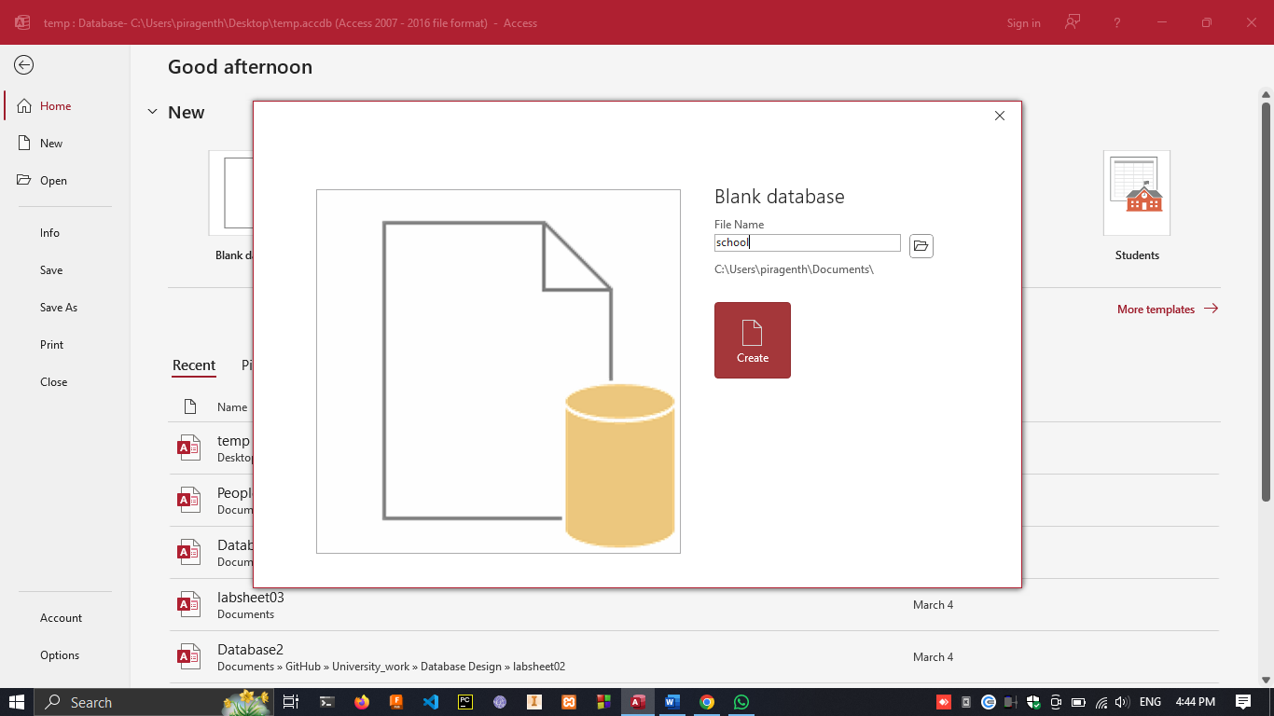

1. click on view -> design view

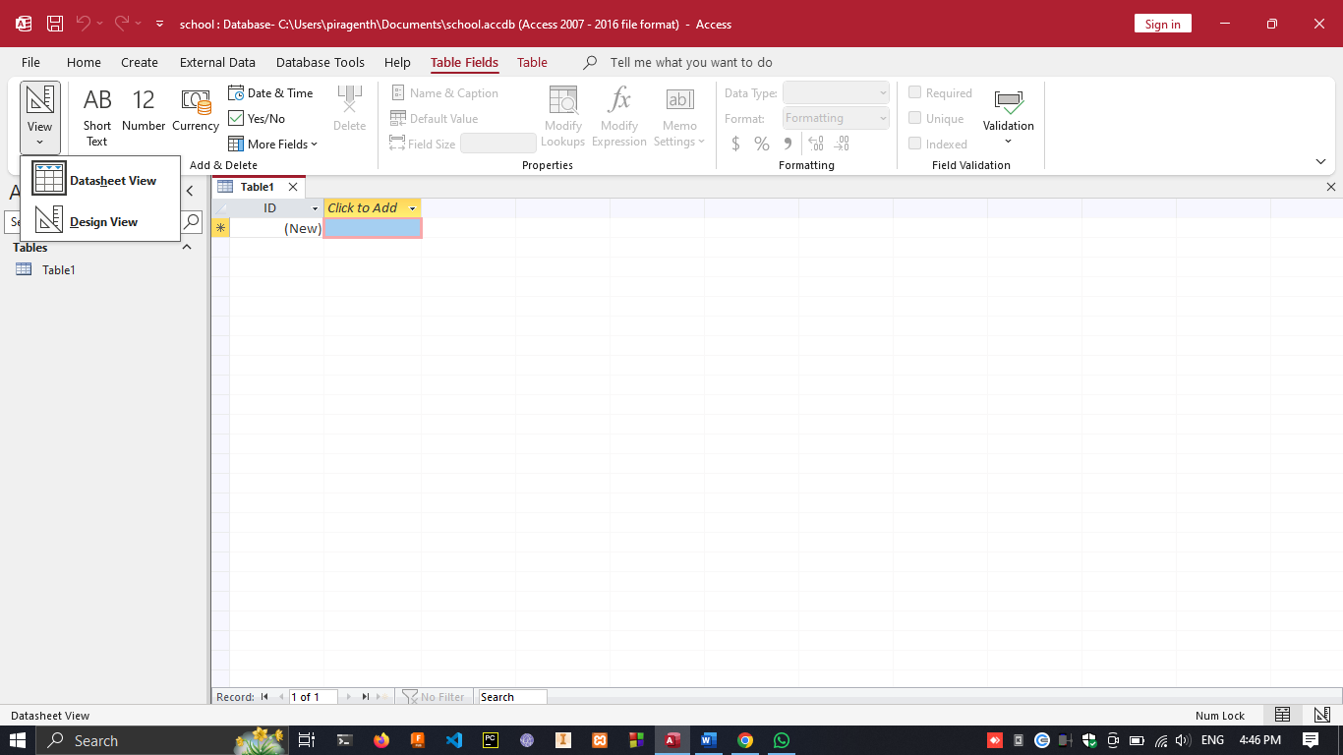

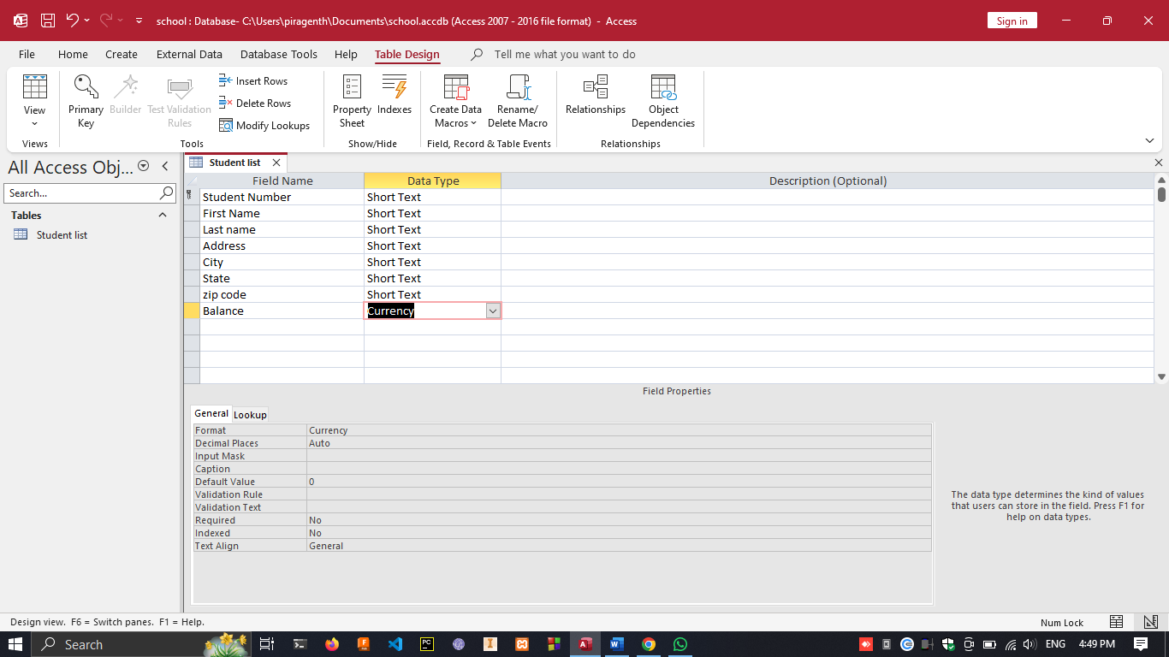

1. adding data to the table

